**Introduction to Computing**

Introduction to Computing - Lab 4

# Topic : . Variables and Inputs

# Objective

* Learning how to use variables.

# Outcomes

1. Students will be able to identify the nature of problem and its solutions through code or algorithm.

# Content

The following topics require revision for this lab session:

Just a bit of knowhow that how to code.

Details of these topics are given below:

# Instructions:

***Important Note:*** Read the Question statement 3 times and understand the problem and analyze the expected output and then design the solution.

Students are required to complete the following tasks in lab timings.

# Reading material

The smallest individual unit of any program written in any language is called a token. C++’s tokens are divided into special symbols, word symbols, and identifiers. Following are some of the special symbols:

**Special symbols:**

Special symbols are the operator which are used to perform different operations like:

1. Arithmetic operators (+, -, *, /, %)
2. Logical operators (&&, ||, !)
3. Relational operators (>, <, >=, <=, ==, !=)

**Word symbols:**

Word symbols are the reserve words, which are used for different purpose. Reserve word are also known as key words.

Some of the commonly used key words are: int, float, double, char, void, return, if, else, while, for.

**Identifiers:**

C++ identifier consists of letters, digits, and the underscore character (_) and must begin with a letter or underscore, no other symbols are permitted to form an identifier. C++ is case sensitive—uppercase and lowercase letters are considered different. Thus, the identifier NUMBER is not the same as the identifier number. Similarly, the identifiers X and x are different. It’s a good practice to define meaningful identifier name, like if u need to store salary of a person than identifier name should be salary not a, b or c.

**Data Type:**

Data type is a set of values together with a set of allowed operations. Integral, which is a data type that deals with integers, or numbers without a decimal part. Floating point, which is a data type that deals with decimal numbers. Some of the data types which are commonly used are: integer(int), floating point(float), character(char), Boolean(bool).

**How to define an identifier?**

Whenever we use an identifier first we need to define it otherwise system creates a syntax error (undefined identifier used). So we need to learn how to create an identifier.

**The generic way of define an identifier is:** dataType IdentifierName;

When we declare an identifier it holds a value which is not assigned by user so for user this value is considered as garbage value. So, it is a good practice to assign a value to an identifier at the time of creation which is called initialization.

**Initialization statement:**

Assigning a value at the time of declaration of a variable is called an initialization statement.

**The generic way of initialize an identifier is:** dataType IdentifierName = value;

In case of integer, float, double:

int noOfStudentsInClass=45;

float averageOfClass=60.5;

double length=5; or double length=6.85;

but in case of character and boolean the way of initialization is different.

In case of character assigned value is written in single quotes.

char grade=’A’;

In case of Boolean assigned value is written as true or false. But we can also write it as 0 or 1 form. 0 represent as false and 1 represent as true.

bool isNumberFound=true or bool isNumberFound=1;

**Can we change the value of an identifier?**

Yes, we can change the value of an identifier. There are multiple ways of doing this. We can change the value by assigning method and input method.

**Assigning method:**

There are two ways which are used as assigning method assigning value and assigning another identifier.

**Assigning a value:**

Identifier= value;

**Assigning an identifier:**

Identifier=identifier;

**Is there any difference between assigning statement and initialization statement?**

Yes, in initialization we assign a value at the time of creation of an identifier. On another hand in assigning statement, we assign a value to an already defined identifier.

# Tasks

## Task 1

Write a C++ Program that will initializes an integer variable with any given value and prints the variable using **cout** statement.

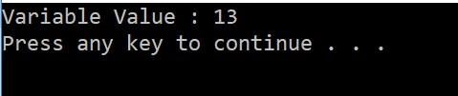

## Task 2

Write a C++ code that creates an integer variable and inputs its value using **cin** statement and prints the entered value.

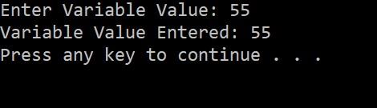

**Task 3**

Write a Program that creates two integer variables and inputs their value using **cin** statement and prints their **SUM, DIFFERENCE, PRODUCT AND DIVISION.**

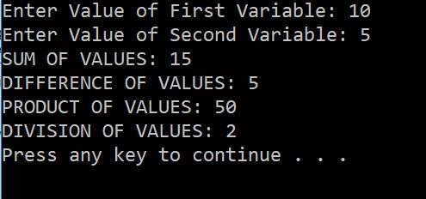

**Task 4**

Write a Program that will print a table of a given number. Create an integer variable and inputs its value using **cin** statement and prints the entered number’s table.

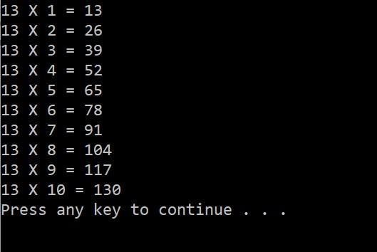

## Task 5

Write a C++ program that creates 4 integer variables name **Fuel, Rent, Bills & Total**, the program must input the first three variables and calculates their sum and print them in a tabular form.

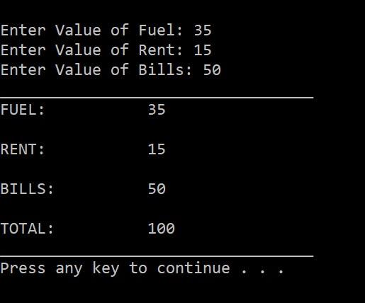

## Task 6

Write a C++ program that creates variables for a result sheet and input their value from user and print them in a formatted manner.

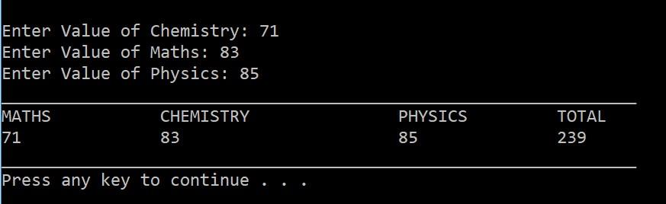

**Task 7**

Write a C++ program that inputs price and quantity of the following items and print the total value. The items are **Wheat, Rice & Sugar. (Value = Price * Quantity)**

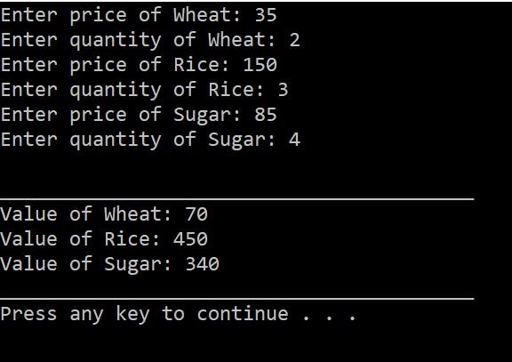

## Task 8

Write a program that takes 3 numbers from user and print them in reverse order

**Sample Input:**

**Please Enter 3 numbers: 12 20 5**

**Reverse is: 5 20 12**

**Task 9**

Get hours and minutes as input from user, and calculates the total number of minutes.

**Expected Output:**

**Enter hours: 5**

**Enter minutes: 37**

**Total minutes: 337**

**Task 10**

Get minutes as input from user, and display the total number of hours and minutes.

***Expected Output* :**

**Enter minutes: 546**

**9 Hours, 6 minutes**

## Task 11

You have to write a C++ program that will have two variables [x and y] both integers, you have to assign some value to the both variables, and then you have to show [**Let x = 25, y = 13**]

**Your program should show the following output on the screen**

**Output on the screen should be**

**Value of x is 25 and value of y is 13**

**Sum of x+y is 38**

**Difference of x-y is -12**

**Multiplication of x*y is 325**

**Division of x/y is 1**

**Division of y/x is 0**

**Task 12**

**Now update this program**, add some more variables, and store all the results in the variables, all variables should be integer [Sum, Sub, Sub1, Mul, Div, Div1]

Sum = x + y Sub = x – y Sub1 = y – x Mul = x * y Div = x / y Div1 = y / x

**Output on the screen should remain the same as before now think where you have to use variables to show the results.**

**Value of x is 25 and value of y is 13**

**Sum of x+y is 38**

**Difference of x-y is -12**

**Multiplication of x*y is 325**

**Division of x/y is 1**

**Division of y/x is 0**

**Now again update the program** and get value of x and y as an input from the user

**Please enter value of x: 20**

**Please enter value of y: 32**

**Value of x is 20 and value of y is 32**

**Sum of x+y is 52**

**Difference of x-y is -12**

**Difference of y-x is 12**

**Multiplication of x*y is 640**

**Division of x/y is 0**

**Division of y/x is 1**

**Repeat the other case for the output; use the other variables [Sum, Sub, Sub1, Mul, Div, Div1] for storing result**

## Task 13

You have to write a C++ program that will find the perimeter and area of a rectangle. To find the perimeter and area of a rectangle, you need to know the rectangle’s length and width.

You have to **define two variables** [length and width] and assign values to both. You have to calculate

1. Perimeter = 2 * (length + width)

2. Area = length * width

Let length = 15, width = 21

**Output should be**

**Length of the Rectangle is: 15**

**Width of the Rectangle is: 21**

**Perimeter of the Rectangle is: 72**

**Area of the Rectangle is: 315**

**Task 14**

Change above program and get both length and width values from the user as an input.

**Output should be**

**Please enter length of the rectangle: 22**

**Please enter width of the rectangle: 15**

**……………………………………………..**

**Length of the Rectangle is: 22**

**Width of the Rectangle is: 15**

**Perimeter of the Rectangle is: 74**

**Area of the Rectangle is: 330**

**Task 15:** Convert the following pseudocode to C++ code. Be sure to define the appropriate variables.

Store 20 in the speed variable.

Store 10 in the time variable.

Multiply speed by time and store the result in the distance variable.

Display the contents of the distance variable.

**Task 16:** A car holds 12 gallons of gasoline and can travel 350 miles before refueling. Write a

program that calculates the number of miles per gallon the car gets. Display the result

on the screen.

*Hint: Use the following formula to calculate miles per gallon (MPG):*

*MPG = Miles Driven / Gallons of Gas Used*